1. Write a query to find the students' first name, last name, phone number, and address for those who have the blood groups O+ and A-.

**Query:**

select first name, last name, phone number, address from StudentPersonal

where blood group in ('O+', 'A-');

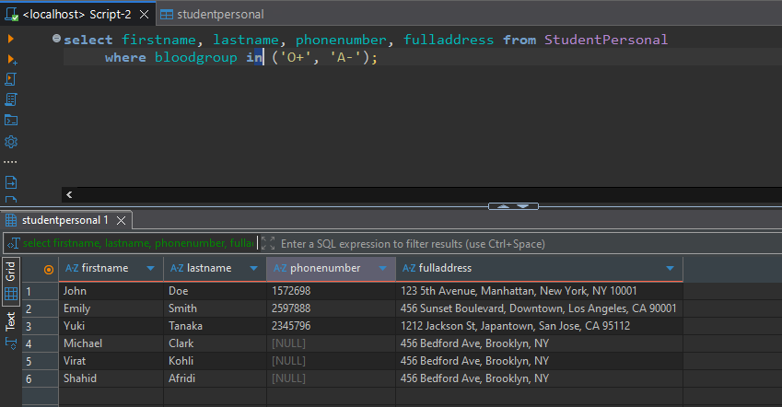

2. Write a query to find the department name, department code, and subject title for the subject with the subject code "EE201."

**Query:**

select dp.departmentname, dp.departmentcode, sub.subjecttitle, sub.subjectcode

from departments dp

inner join subjects sub

on dp.departmentcode = sub.departmentcode

where subjectcode = 'EE201';

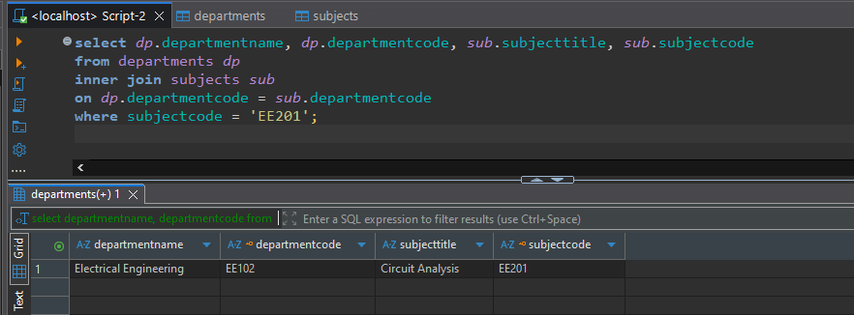

3. Show the count of students for each blood group that has at least 2 students.

**Query:**

select bloodgroup, count(*) as Count_Of_Students from studentpersonal group by bloodgroup having count(*) > 1;

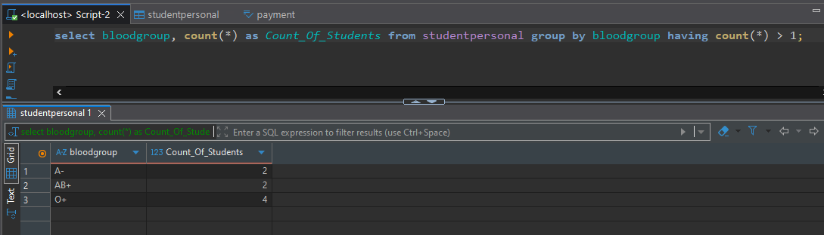

4. Write a query to find the students' first name, last name, and subject title for those enrolled in the department CS101.

**Query: (Need Correction)**

select sp.firstname, sp.lastname, sub.subjecttitle

from studentpersonal sp join subjects sub

inner join subjects sub on sp.departmentcode = sub.departmentcode

WHERE sp.departmentcode = 'CS101';

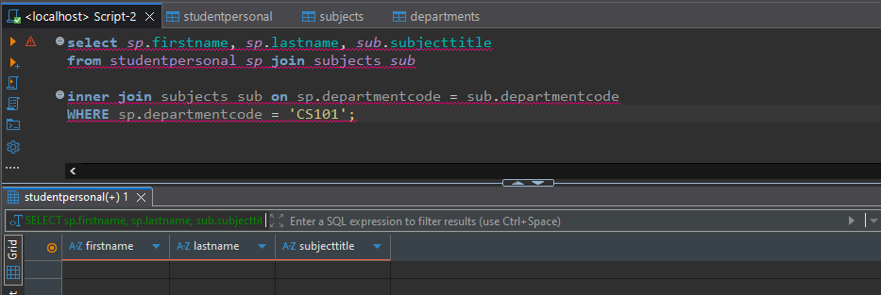

5. Find the total semester fee collected for the Computer Science department.

**Query:**

Select sum(totalSemesterFees) as total_semester_fee from studentacademic where departmentcode = 'CS101';  
  
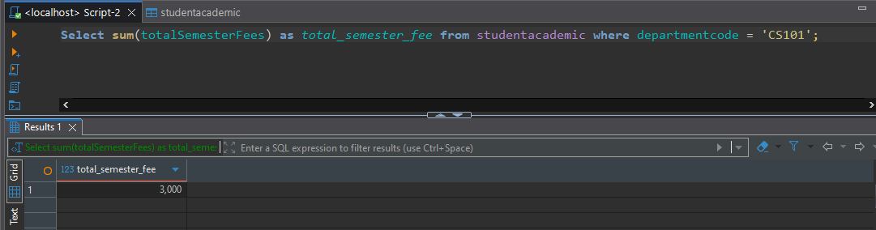

6. Write a query to update the semester fee by 10% for students in the CS101 department.

**Query:**

update studentacademic set totalSemesterFees = totalSemesterFees + (totalSemesterFees*10/100) where departmentCode = 'CS101';

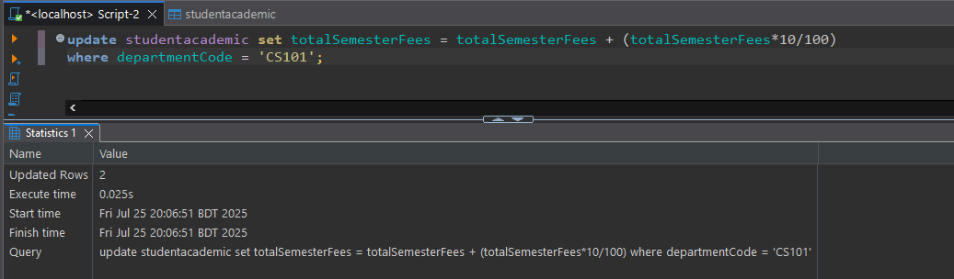

7. Write a query to find the students' first name, last name, teacher's first name, and teacher's designation who are enrolled in the course CS101.

**Query: (Need Correction)**

select sp.firstname, sp.lastname

from studentpersonal sp

Union

select tp.lastname, sa.semester, ta.designation

from teacherpersonal tp

inner join teacheracademic ta

where departmentCode = 'CS101';

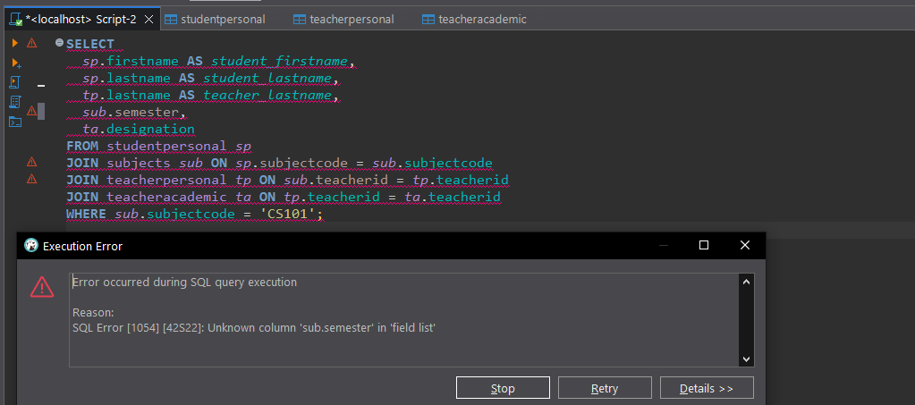

8. Write a query to show the student's first name and the teacher's last name where both the teacher and student are from the same city.

**Query:**

select sp.firstname, tp.lastname

from studentpersonal sp

inner join teacherpersonal tp

on sp.city = tp.city;

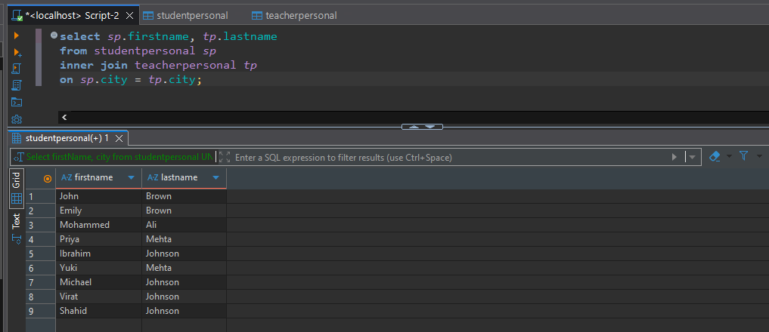

9. Write a query to show the student's first name, last name, email, subject code, and subject title for the students enrolled in the subject "Algorithms."

**Query: (Need Correction)**

Select firstName, lastName, email from studentpersonal UNION select subjectTitle, subjectCode from subjects

where subjectTitle = 'Algorithms';

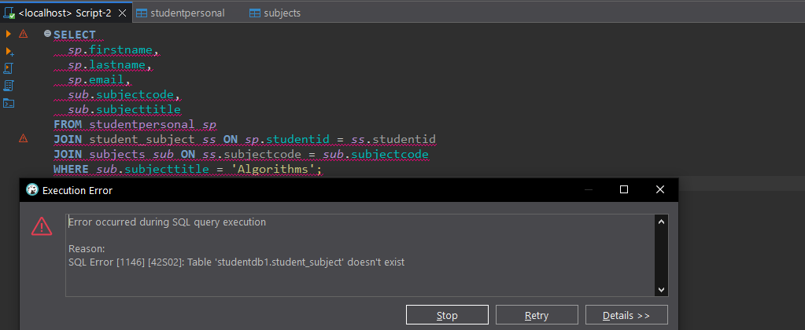

10. Write a query to promote teachers who are currently Lecturers to Sr. Lecturers, and promote Sr. Lecturers to Associate Professors.

**Query:**

update teacheracademic

set Designation =

CASE

when Designation = 'Lecturer' then 'Sr. Lecturer'

when Designation = 'Sr. Lecturer' then 'Associate Professor'

else Designation

end;

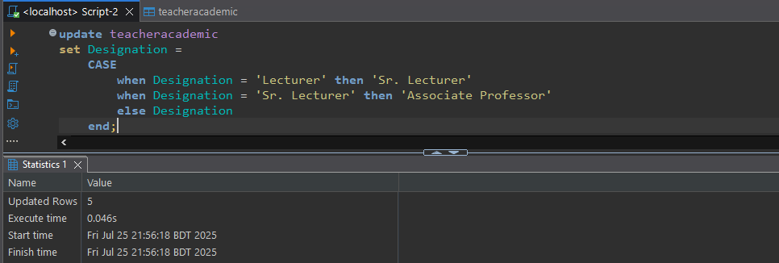

11. Write a query to find the teacher's first name and last name who has the second-highest salary.

**Query: (if possible, other, so comment it)**

SELECT tp.firstname, tp.lastname

FROM teacherpersonal tp

JOIN teacheracademic ta ON tp.teacherId = ta.teacherId

WHERE ta.salary = (

SELECT MAX(salary) FROM teacheracademic

WHERE salary < (SELECT MAX(salary) FROM teacheracademic)

);

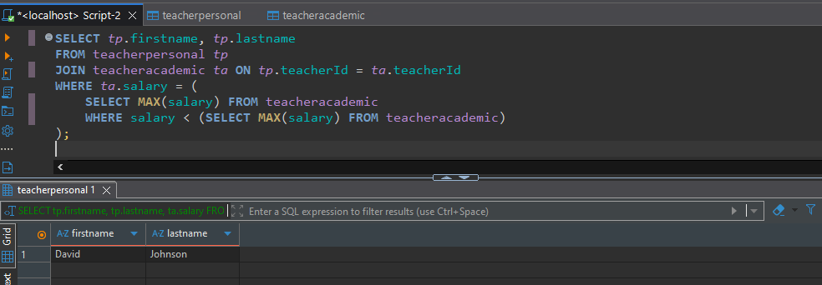

12. Write a query to find the teacher who has the second highest salary and list the students enrolled in their course. Show the teacher's first name, last name, and the students' first name, last name, city, and department code.

**Query: (Need Correction)**

select sp.firstname, sp.lastname, sp.city

from studentpersonal sp

join studentacademic sa

on sp.studentId = sa.studentId;

Union

select sp.studentid, sp.firstname, sp.lastname, sa.semester

from teacherpersonal tp

join teacheracademic ta

on tp.teacherId = ta.teacherId;

where ta.salary = (

select max(salary) from teacheracademic

where salary < (select max(salary) from teacheracademic)

);

